Sister Act Scene Transitions (actors can be asked to do any of the moves as long as they are in the scene or have time between scenes)
Scene: | Location: | Props:
ACT I
I-1, 2, and 3 | Audition Room  “stage” made of two 9 in benches with two 18 in benches in between using two #4 tarp straps to hold benches together; columns lit with purple lights (hide top light), pull back black curtain to sides of columns  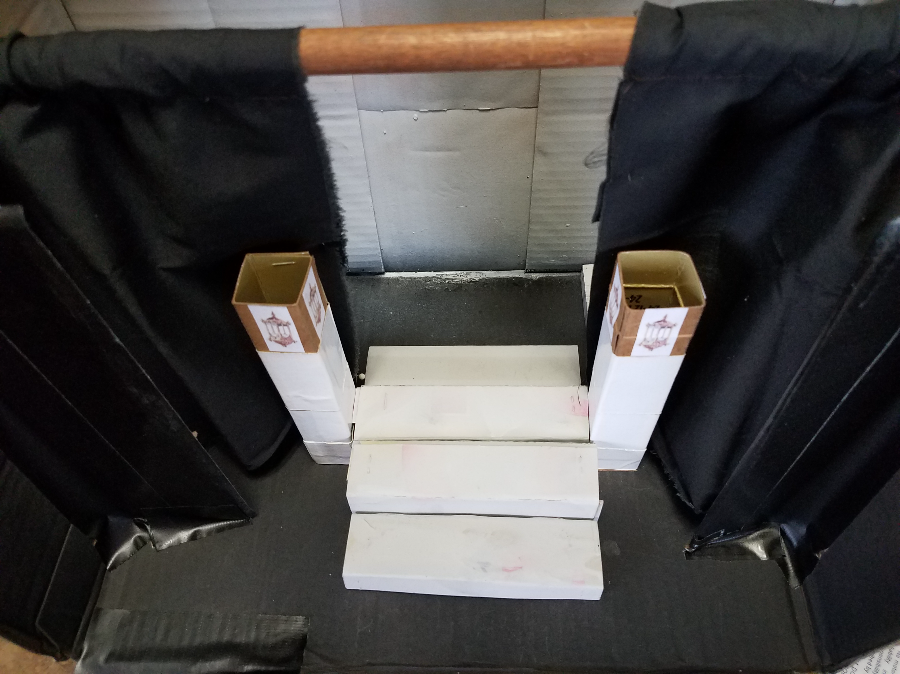 | NOTE: Dan Augspurger (waiter in the scene) will begin clearing tables and chairs off of stage during scenes 1 and 2 to open up the stage for scene 3, the chase scene (please assist him by being just off-stage to receive tables and chairs)
I-4 | Police Station (north end of apron)  Permanent : Eddie’s desk and chair, chair for guest, telephone, typewriter, 1977 Most Wanted posters on vents with magnets, inbox, flag, bulletin board with notes, Evidence Locker sign, map of Philadelphia | During this scene, set up Narthex  Move benches to back wall and stack
I-5 | Narthex  2 rolly set pieces flanked with columns (lit top lights), convent gate in between  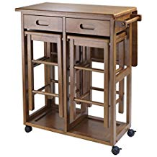  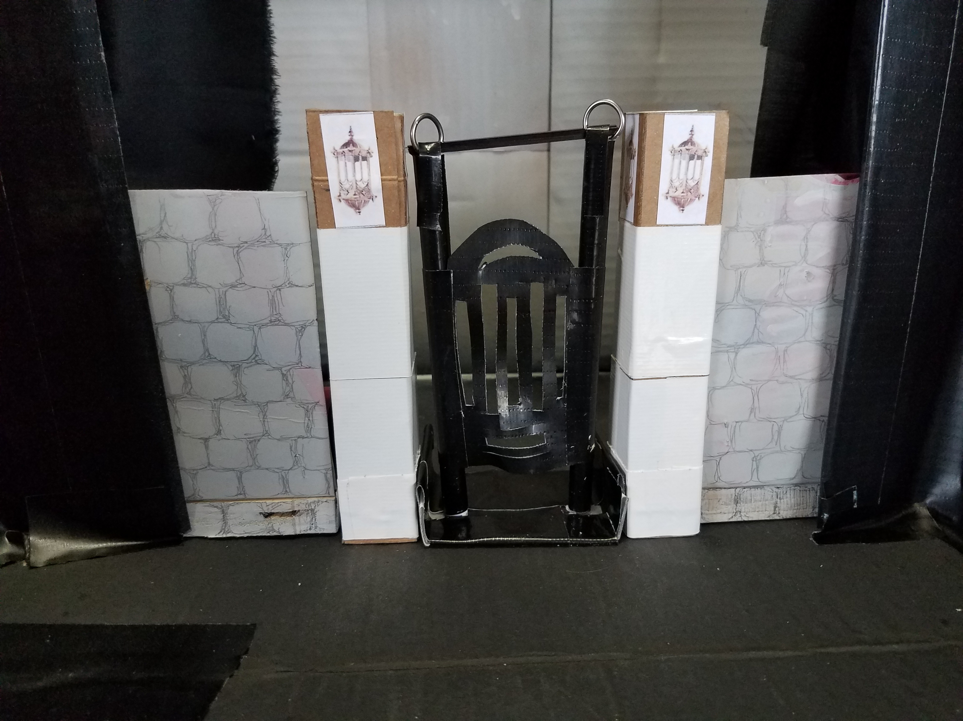  Stored onstage Mother Superior’s Office: spacesaver table with stools, phone, papers, Bible in drawer | Remove gate (don’t need it again this show)  During this part of the scene, set up Dining Room  Prepare tables (bowls and spoons) and benches to be moved forward by nuns when curtain opens.
I-6 | Dining Room  2 rolly pieces with space in between, 3rd rolly piece against back wall flanked by columns (lit top lights)  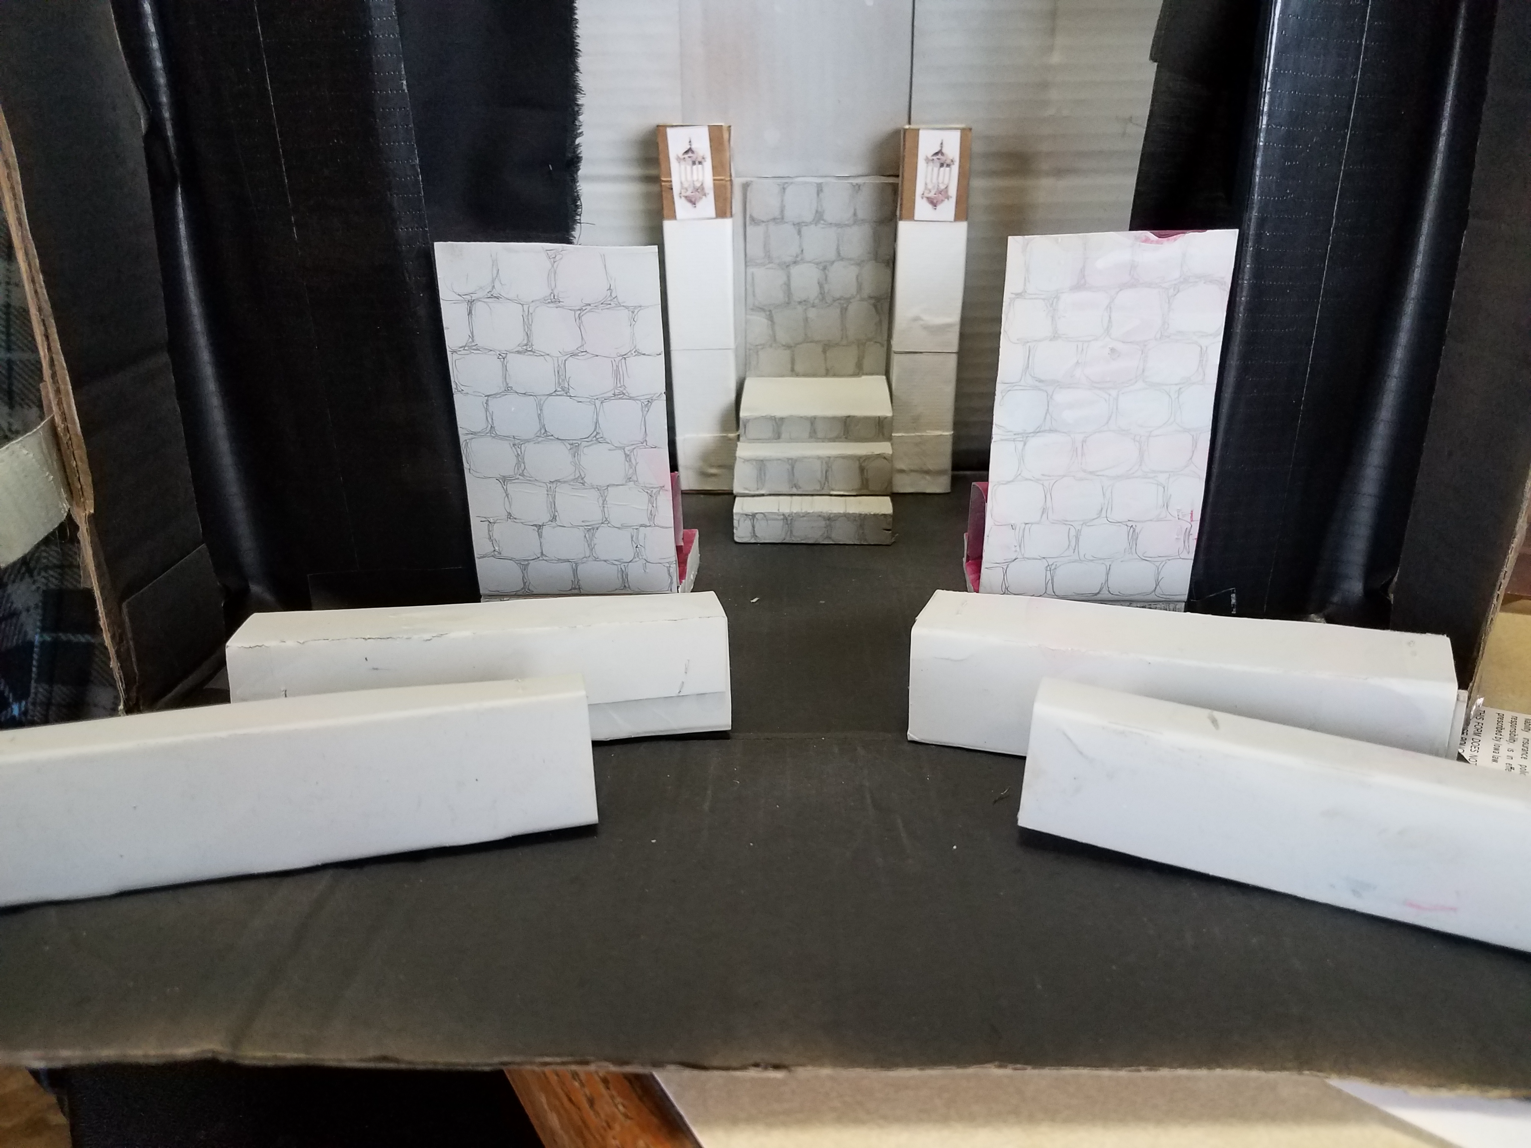
I-7 thru 9 | Chapel  In front of front black curtain | Set up bar scene
I-10 | Bar  2 rolly pieces together flanked by columns (top not lit, neon green lights down sides) | At front black curtain closing, strike bar and put all behind back black curtain
I-11 | Street by Bar  In front of front black curtain, close back black curtain, open front one for dance, then reverse | At front black curtain closing, set up music room. Nuns will move benches forward when curtain opens.
I-12 | Hallway  In front of front black curtain
I-13 | Music Room  2 rolly pieces side by side SR, maroon rolly piece on left end of those with columns behind (top is lit)  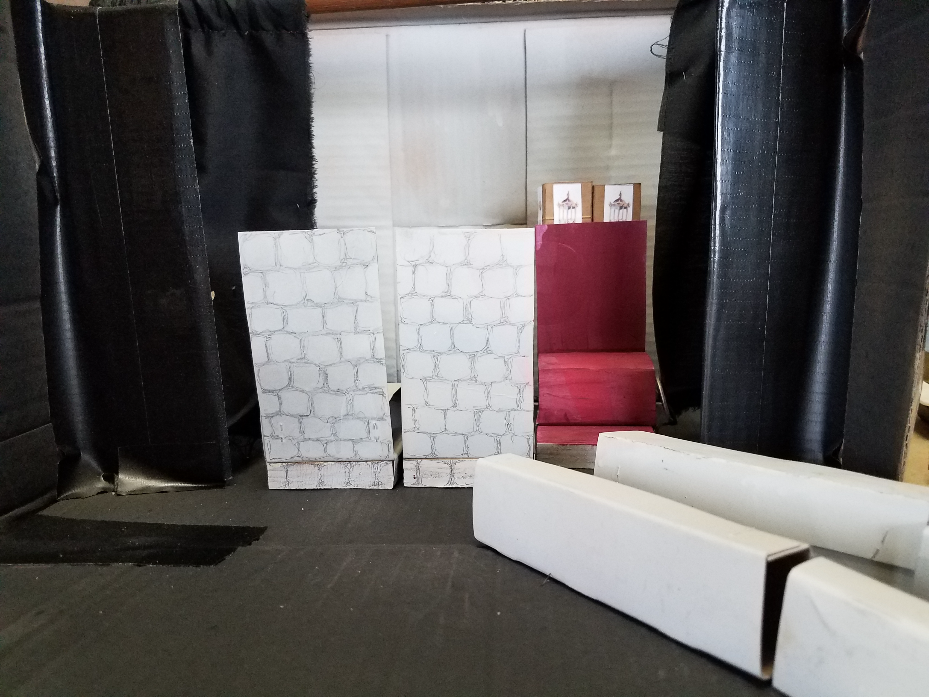 | FAST SET CHANGE TO CHURCH SET:  Remove one rolly piece (grey on both sides)  Bring stained glass window forward  Move in columns with flowers hanging  Change benches to riser configuration
I-14 | Church service  2 rolly pieces separated by the church window (#2 tarp straps to hold riser benches together), columns on either end of rolly pieces (both top and white lights lit)  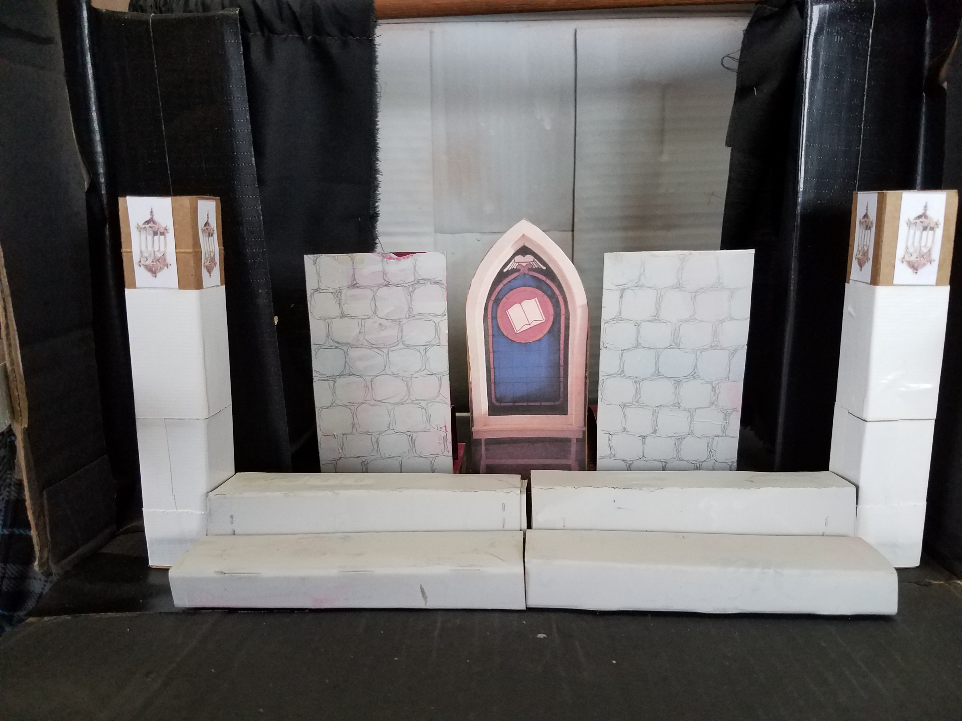 | After red curtain closes, set up confessionals.  Will need this church set again in Act II, Scene 2, so keep things at hand.  Use 2 rolly pieces (maroon) as confessionals  Stand benches on ends on sides behind black front curtain  Keep columns where they are if possible  Pull the stained glass window back and to SR out of the way (will need to move confessional wall back through this space)

