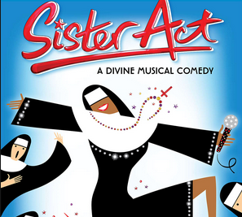

“It was Joey!”

AWARD

Russ Mikels

has been recognized for outstanding contributions to Sister Act.

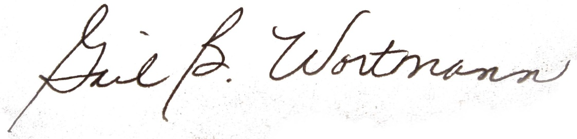

**November 8-11, 2018** ___________________________________

Director