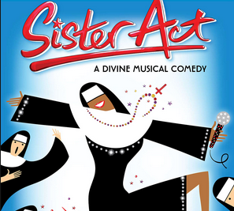

AWARD

has been recognized for outstanding contributions to Sister Act.

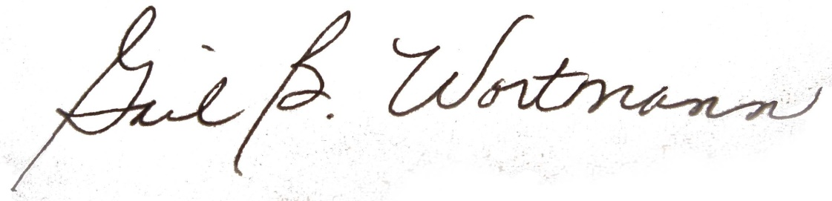
November 8-11, 2018 ___________________________________
Director

